September 27, 2009

Wang Qingsong (b. 1966, Heilongjiang, China, currently living and working in Beijing)

Interview for Art Asia Pacific magazine

These conversations took place in Beijing at our Cao Changdi Village compound no. 241, where we are neighbors. Wang Qingsong maintains a live-work studio space in this Ai Weiwei-designed community of workspace for artists, galleries, filmmakers, designers and architects. Wang keeps another home and studio in Tongxian, (Beijing’s rural outskirts approx 30 miles east of the city) where he first settled in 1993, and where he plans to build a new studio space in 2010.

Meg Maggio: A lot is written about your earlier artwork, your move to Beijing, your early painting work, your pioneering staged photography work, and your recent installations.

In this interview, I would like to focus instead on your recent video work; on how and why moving images can be preferable as a medium for expression, and particularly, the three single channel videos you just finished, and your show at UCLA’s Hammer Museum, (Wang Qingsong: Hammer Projects solo exhibit curated by Jaime Elaine, Mar 24-Jun 14, 2009).

Since these three videos were made nearly at the same time, I am interested in exploring your thinking and experiences during this process. Please also tell us a bit about your impressions of this your first solo museum exhibit in the USA. What did you think for example of exhibit viewers’ – presumably mainly Americans’ - reaction to your work?

Wang Qingsong: Unfortunately, I did not go to the exhibit. I had 3 exhibits opening at roughly the same time, LA, Havana, and Queensland. I had to go to Queensland to install a new work, a massive installation based on my photograph "Competition" for the show called "Three Decades of Collecting Chinese Contemporary Art", so there was no way to go to LA.

As for working with Hammer Projects, I found the project space format very fast and very smooth, sans the usual long and drawn out museum decision-making process. The exhibit was decided within one month; compared to other museums I found the quick scheduling very exciting. The museum director also knew my work and visited my Beijing studio, so the exhibit proposal and acceptance process happened quickly.

Jaime (Elaine) was at the LA opening, and when he returned to Beijing (where he now resides much of the time) he told me the audience reaction was very positive. The Hammer wants to collect the video and is looking for donors. My understanding is that the Hammer collects mainly non-video work, and was having trouble finding funding; perhaps this is typical now due to the USA economic downturn.

Despite not being there, I heard a lot from friends who went to see it and sent positive feedback. Friends who saw the work were surprised to learn I was making video work.

WQS: Initially, our plan was to show all three videos. Later the Hammer opted for just "Skyscraper", and I was told the format of the other two wouldn’t fit the screen well. However, I suspect the violence depicted in the other two videos influenced the decision not to show them.

Meg Maggio: In Skyscraper (2008), your first video work, you build a 35 meter tall “skyscraper” from iron scaffolding painted gold, you pay 20-50 scaffolding workers to do the job, and you direct the shooting with stop-action 35 mm film over a one month process.

How did the workers’ view your “construction” project, how did you describe your work to them, how did you direct the shoot, and how did you manage to engage the workers in your artwork on a day-to-day basis. And finally, why did you choose to erase their presence in the final edit? I am interested in this aspect of social interaction in your work.
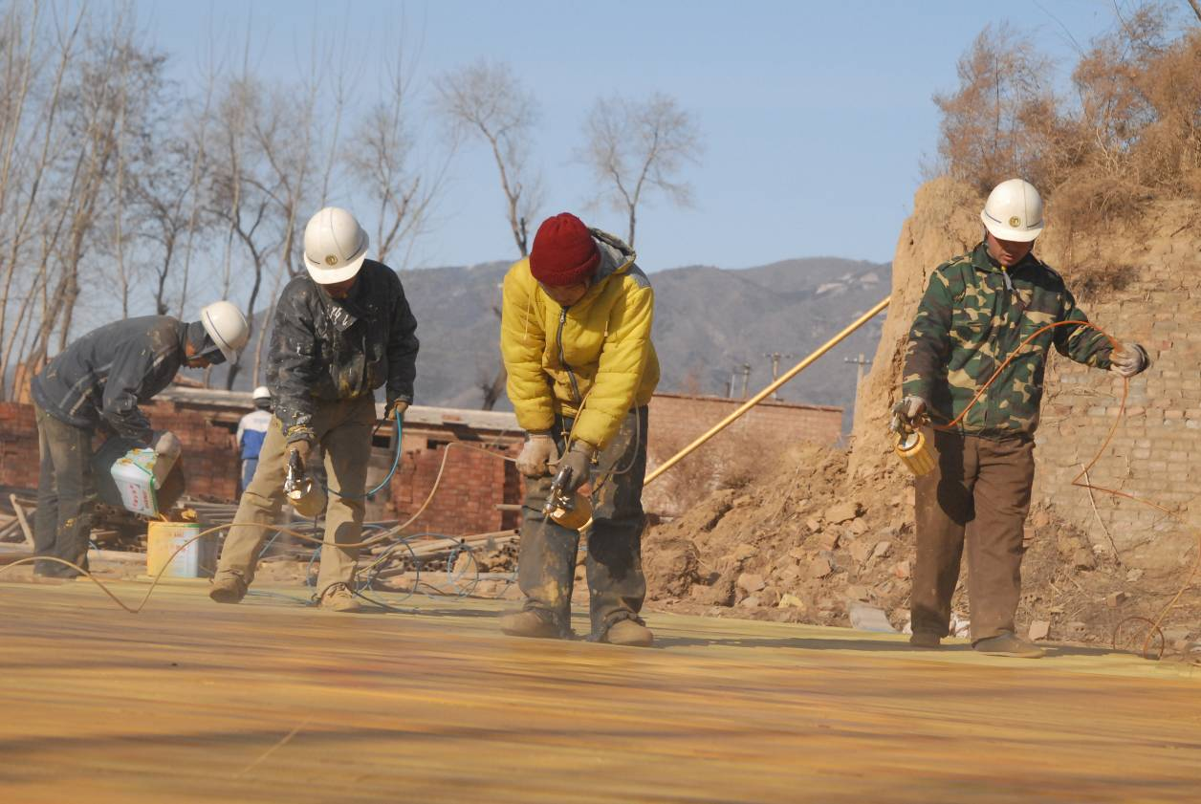
Wang Qingsong: First, I found a really good outdoor site where we could shoot. I really liked the snow capped mountain in the background and initially hoped to shoot a light snow fall. Actually, it's Jundu Shan, a popular local weekend ski resort. I rented the land in Changping - still undeveloped - from the man who leased the scaffolding to me. It was just next to the scaffolding place. The same guy helped me to find skilled and certified scaffolders. I hired skilled workers, so no risk of accident, although it was all a bit dangerous.

There are no workers in the shots, I didn't edit them out. So this was a really slow shoot; they would build a little and then climb down so I could shoot a little.
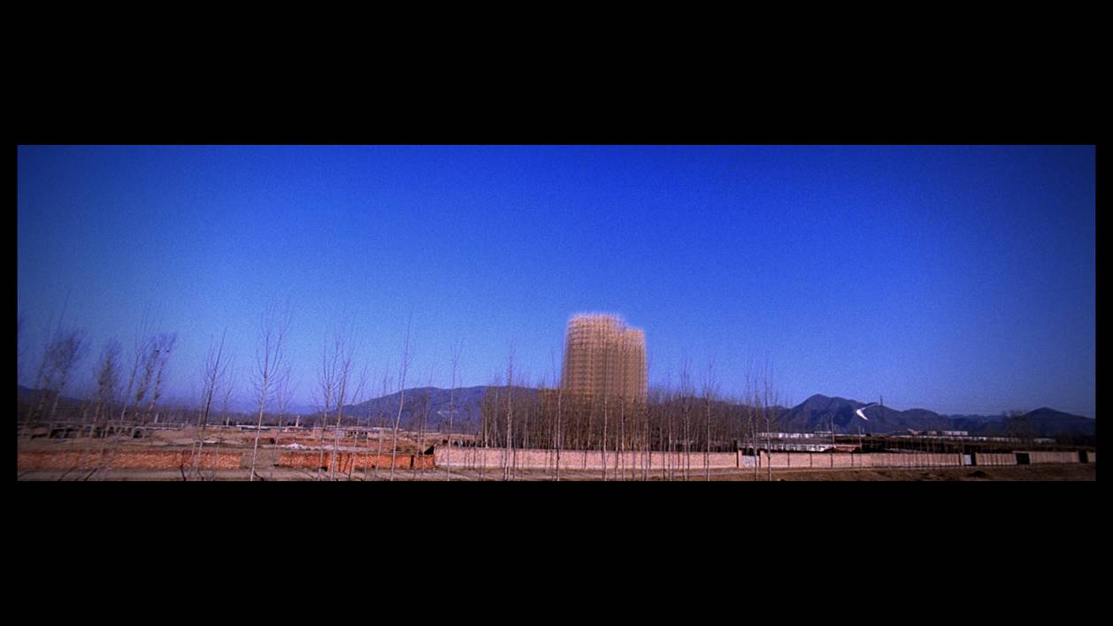
Video still from "Skyscraper", 5 minutes, 35mm, 2008

I opted to omit workers from the visual narrative, by omission pointing to the fact that Chinese development is deeply rooted in the contribution of workers. Real estate development is a story of itinerant workers, poor workers, who can never afford to live in the buildings they are constructing. Most real estate development, in fact, does little to solve the housing problems of construction workers.

I didn't explain a lot to the workers during the shoot, I just told them I was making a public service ad. If the local people know it's for a film or tv commercial ad, they bother you for money. My explanation keeps costs down and keeps things simple. If I mention art, an ad or a film shooting, the price goes up and things get more complicated. Police always come to see what you are doing. I kept things simple, so no big safety issues would come up, and costs would stay low.
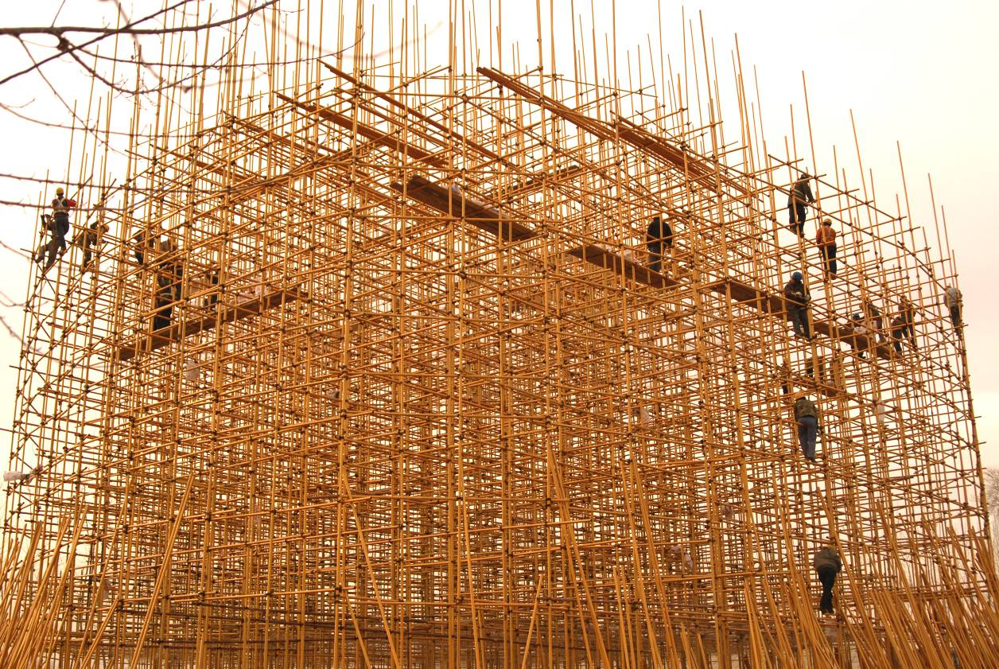

I always try to keep things simple. I supply meals and a bonus at the end, when everyone inevitably starts complaining that the shooting is tougher and longer than they imagined. The process of finding workers is a bit bureaucratic, because scaffolding workers have specialized skills and licensing requirements. I sign a contract with someone who supplies workers; I make a model of my "skyscraper" and they follow it, and the height requirements dictate the safety and experience of workers.

We finished three days before Chinese New Year, so everyone was happy to finish and to start the holidays. Of course I also had to throw in an extra 2000 RMB Yuan half-way through the job, as incentive bonus, and because there had been no accidents. So, you need to pay to get it finished.

I also had to add a bit at the end, as workers are bound to complain the project is tougher than initially described. I have friends in the movie business, so I know the hassles of shooting on location.

Initially, there were nice trees on the land, and the owner tried to sell them to me half way through the shoot. One way or another, they try to take your money half-way into the shoot, because they know you have to finish. I told him I did not need to buy the trees, and the guy cut about 50 of them down anyway, and probably sold them off to someone. We were not shocked that the guy would quickly cut down 50 trees like that, he started with about 500 trees and quickly cut down 50 and sold them. He probably needed the pre-Chinese New Year additional cash.
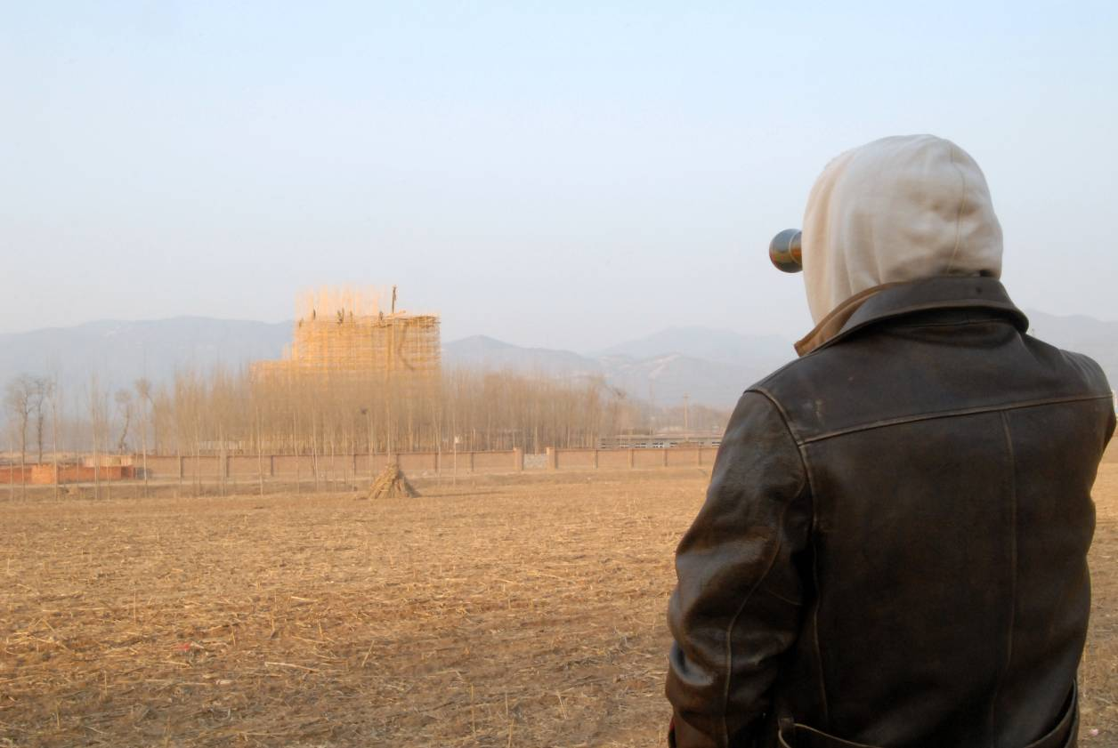

Meg Maggio: I’ve heard you talk about the difference between a “big country” and a “strong country” describing China as "big" in many ways, but not necessarily "strong". Did this view of China influence Skyscraper?

Wang Qingsong: Yes, this notion is reflected in the "Skyscraper" video. On the surface my "skyscraper" looks beautiful and attractive. However the reality is that the real product is riddled with problems. The same can be said for many Chinese products.

One way to measure Chinese economic success is through its real estate development. Real estate development is also an easy way to impress people. The popular and of course erroneous belief is, "The larger the real estate project, the taller the skyscraper, the better the development". We have a kind of de facto competition not only in Beijing but in all major cities, which is a race to build the tallest, the biggest real estate project. Do all our cities really need this rapid real estate development that we are constantly told is fast approximating - and hopefully surpassing - international styles and international levels?

I come from a small ancient city Jinzhou, In Hubei province, where I grew up. And I suddenly find out that Jinzhou is building one of the most gigantic factory buildings in the country, bragging that it will be the same size as Tiananmen Square. Is this a joke? Does it really need to be that big? Today, Jinzhou, the city where I grew up, despite its illustrious historic importance from ancient times, is very poor, with old state factories shutting down due to lack of funds, and changing to other lines of work, and it is a mess during this transition.

I want to contrast the poverty of the countryside with the invasion of a skyscraper, as it reflects reality. The reality of life in the countryside is reflected in so many incidents I experienced during the shooting. Many people came to see the shoot, including local officials who wanted to know what I was up to, and probably wanted to know what if anything was in it for them. I said I was a photographer helping my boss to make a public service ad saying about the urbanization of the countryside. This explanation usually sufficed. I always think: The less said at these moments, the better.
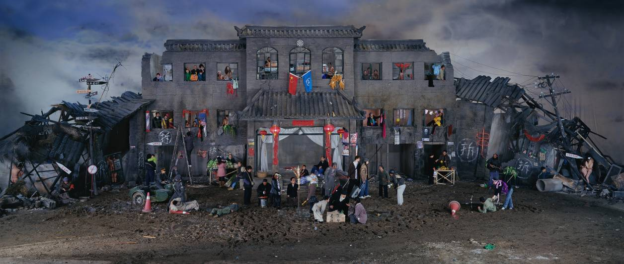
Dream of Migrants, 170x400cm, 2005

The slogan we hear all the time these days is "A New Countryside", meaning the promise of a new and better life for those living in the countryside. We are constantly bombarded with the idea that we need to change the countryside. Around Beijing, we hear a lot about the areas bordering the city outskirts. The message is that rural life in these city outskirts will be better, richer, and every country dweller will one day soon enjoy the comforts of city life, with the same high standards of living. In order to build this "New Countryside", farmers in areas close to cities are being encouraged to use their land to build - as well as to sell - real estate, or to go to work in factories; and are discouraged from growing food or farming. The government message is to persuade farmers to engage in other industries, mainly real estate and factory work.

Growing vegetables won't make them any money. The wide spread belief is that the road to riches is to sell the land and to engage in real estate speculation. This way, the countryside guys become city dwellers. They become urbanites. Before, the folks in the countryside were prohibited from real estate transactions. Now, the policy has changed, and loopholes can be found. Those former rural people, living near to the city, want to be designated as city residents; then your land prices go up, you get rights to sell or sublease the land, and you make your fortune. You can't sell land in the countryside designated for agricultural use so easily. Finding these loop holes in the policies and laws is one part of the getting rich process.

Meg Maggio: You often talk about China’s uncertain future, how in your view, nothing is clear when you look at China’s future. I’ve also read statements of yours stating your belief that today's behavior and attitudes are the ingredients that inevitably mold the outcome of our future, regardless of how conscious we are about it. Are these ideas reflected in your new video work?
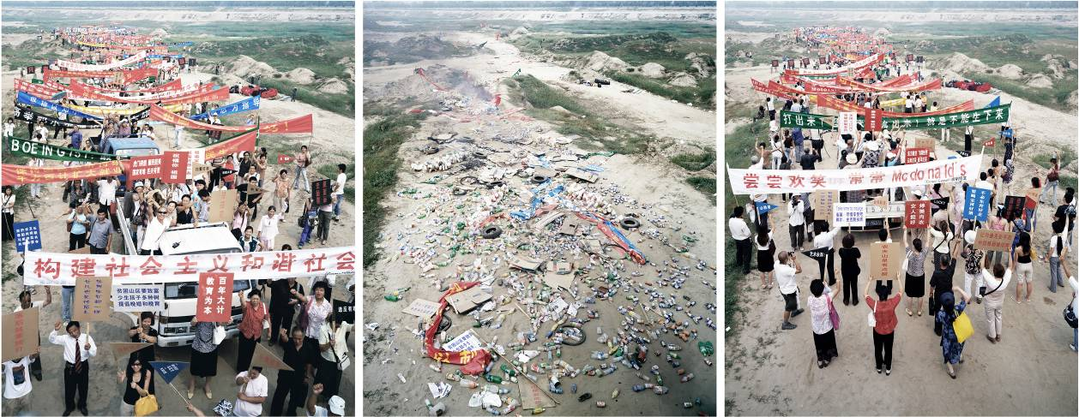
Come! Come!, 200x170cm x 3 pieces, 2005

Wang Qingsong: Yes, I believe there is an on-going contradiction between what happens now and what will happen in China's future. There is the threat of something uncomfortable, something uncertain, even something violently uncertain, lurking just around the corner.

Actually, this on-going tension between today's rural and urban residents and life-styles has already been experienced by Japan and Taiwan in ways that are similar to ours now. The policy encourages you to sell your land. But what happens when rural residents sell off their land and they have no more land rights eg source of capital in their hands? Today, land is expensive, so the government policy continues to push people to sell now. This kind of aggressive government policy pushes people to act quickly. Then, what happens after all the land is sold and there is no land and insufficient money remaining? Will we feel cheated by the government authorities and their policies?

There is often a vague feeling of being cheated, whether in our educational system or in our economic system. We see new problems arising in regard to the university entrance exam system. This year, there was a big problem because less people signed up to take the university entrance exam. This came as a shocking revelation to many, showing a real change in attitude, with higher numbers opting not to take the exam. Better to go to work and to make money.
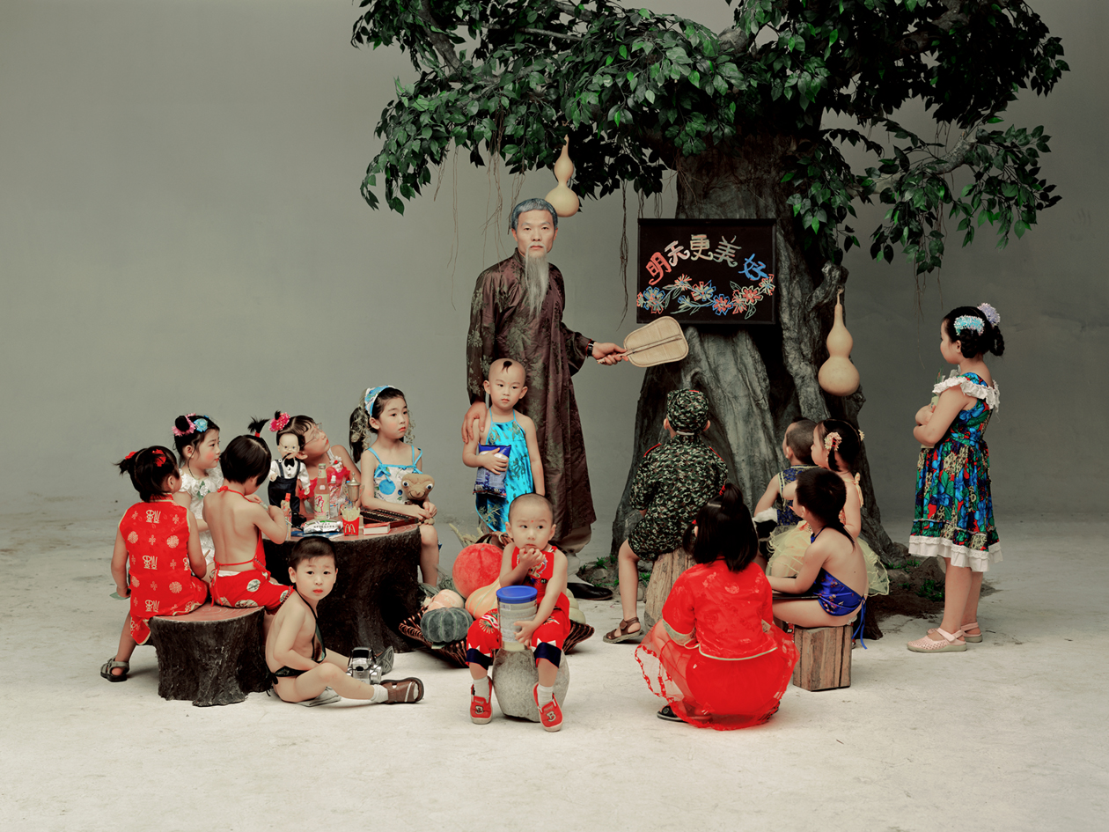
Preschool, 120x160cm, 2002

People are questioning the status quo and whether the education system and the high cost of success within that education system will really do me any good? The underlying fear is that the government is getting richer and average people are getting poorer.

The cost of living continues to rise, and salaries aren't going up proportionally. Government profits go up and our income does not rise accordingly. We see in the news that our foreign reserves have surpassed those of Japan, but in Japan the money is in the hands of the people and in China the foreign reserves remain in the hands of the government.

Meg Maggio: At the end of Skyscraper the sky lights up with a flourish of fireworks and “Silent Night” plays softly then slowly fades away. Why fireworks? Why “Silent Night”? Skyscraper seems deliberately theatrical to me, more about the building of a new monument to office building, rather than being about recording actual construction. Skyscraper, after all is hardly a sincere architectural rendering. Besides the obvious issues related to urban high-density buildings encroaching on China’s countryside, why “build” your Skyscraper?
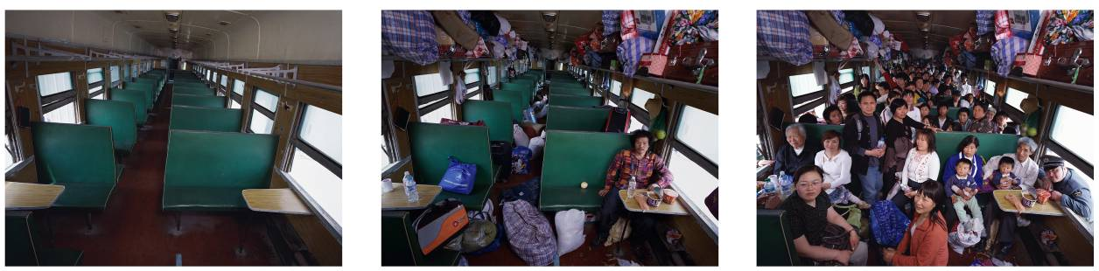
Hard-seat Compartment, 160x210cm x 3 pieces, 2008

Wang Qingsong: First, adding "Silent Night" came from a specific experience I had in Beijing. I used "Silent Night" in the video because it is beautiful and idealistic and happy, and because both the song and the fireworks are associated with celebration and good tidings in China. I see this optimistic attitude in stark contrast to the reality of rampant construction and real estate development in the rural areas bordering China's cities.

Initially, I thought of using Buddhist music. However, after I went with a friend to a church in Beijing, I changed my mind. I had never been to a church service before, and seeing one at Christmas time left a strong impression. When I went in, and saw a bit of the service, and heard the music, and saw people taking something to eat, I was really shocked at the size of the turn-out, how many old people, how many average working class people, mostly people with no money. I was really shocked by how many people were queuing to get in. There had to be over 500 people in this local church, all poor ordinary people. I thought all these people shared a common desire to find some kind of psychic comfort by going to church. And I was really touched after witnessing this phenomenon.

In the ideal world, the same every-day people attending church service should be able to afford to live in our beautiful new real estate projects. I heard 'Silent Night' in the church and I thought this is a way to placate the people, to console them with nice songs, while they wait for their lives to improve. And in the meantime, the reality is that they get neither sufficient salary nor decent enough housing.
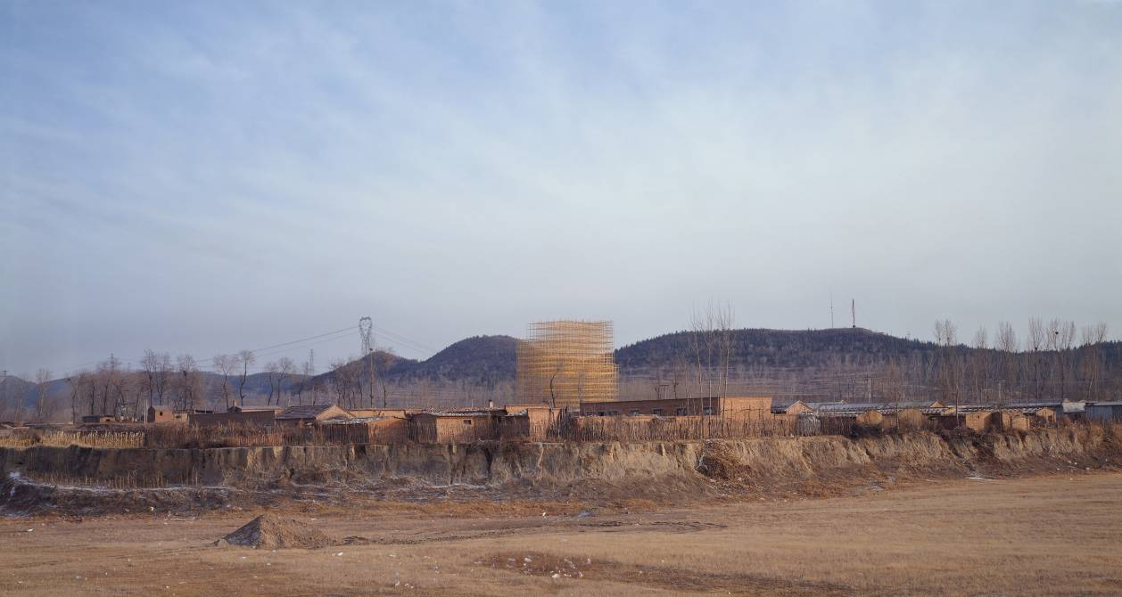
Skyscraper, 160x300cm, 2008

I also like the title "Silent Night" in Chinese translation which talks about peaceful and calm evenings, and the search for a peaceful and calm life.

I add the fireworks because they symbolize a brighter, better tomorrow. Both fireworks and "Silent Night" make us stop thinking about bad things, hardship and difficulty, even if only momentarily. The idea of fireworks in Chinese tradition is to get rid of the bad things of the past and look forward to great things coming in the future. Skyscrapers hold similar connotations.

Meg Maggio: I understand you shot Skyscraper in Changping, in January, outdoors, in one of Beijing’s coldest months. Then, you shot Iron Man in July, starring yourself as sole protagonist, indoors, during one of the hottest times of the year in Beijing. And in Iron Man we get to see you “beaten” to a bloody pulp. You seem to enjoy immersing yourself in these endurance-type situations, regardless of whether you are behind or in front of the camera. Can you comment?

Wang Qingsong: I like the winter for outdoor shoots; less people, more desolate, no leaves on the trees. I would have loved to shoot in the snow, the falling snow. That was my first idea but it was too hard to catch a snow fall in Beijing. We had one night of snow fall, so there is a bit of an evening snow in the video.

I didn't intend to shoot "Iron Man" in the summer heat, but the run up to the Olympics gave me no choice, and like everyone in Beijing, my work was severely limited prior to the Olympics. Work crews and necessary permits were hard to come by. I had little choice in timing.

Technically, "Iron Man" shooting in the summer heat worked to my advantage, because high temps made the makeup of blood and gore more pliable and believable and easier to clean up after. The shots were easier to shoot and came out looking more realistic. I used a kind of wax to give the impression of flesh and blood, and it really works well in hot weather as it melts more on the face in hot temps. 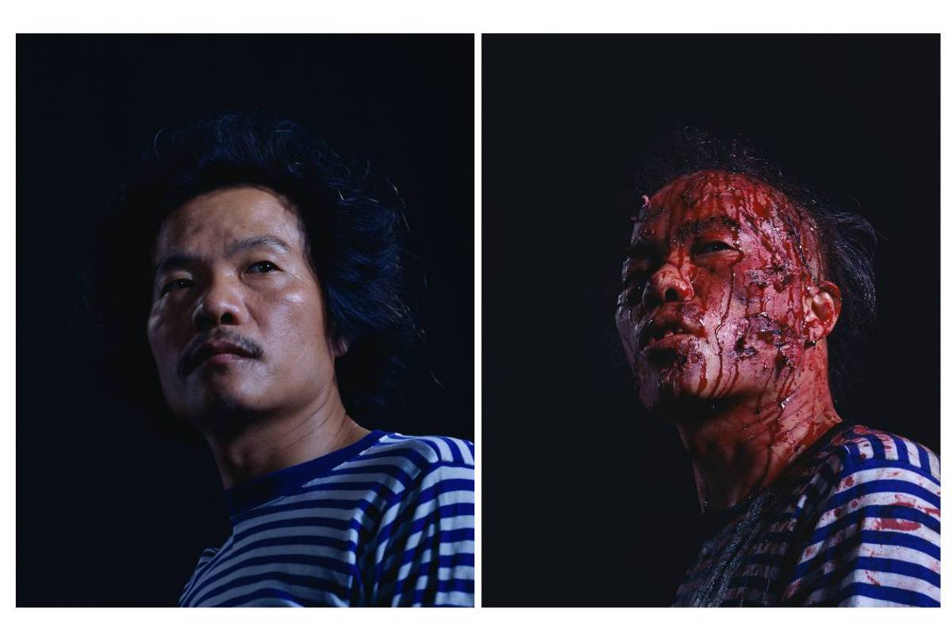
Iron Man, 150x120cm x 2 pieces, 2008

Meg Maggio: For me, the first time watching Iron Man, I found it difficult to sit through, despite its relative brevity, and despite knowing of course that the punches to your face however violent were staged. And I remember asking you how your two small sons reacted when they saw you beat up on camera, and you telling me they laughed and thought it funny! Why funny?

Wang Qingsong: The first time they were shocked, and I immediately told them it was faked. Once they knew it wasn't real they were fascinated and found it funny. Of course I am not happy with how much the kids like violent tv shows and computer games. I noticed lately how often there are bloody scenes in tv shows and computer games. Now, there are many tv series involving law and order and crime fighting with plenty of violent scenes. Audiences get used to it. And there is even violence depicted in many ads. People begin to think that violence can be beautiful and poetic and even worse; that violence is more beautiful when it is realistically done. The closer violence approximates reality, the more successful; and, long drawn out slow motion scenes of violence have increasingly become a respected art form on tv mini-dramas and movie-shoots. The level and style of depicting realistic violence has become a measure of success in much commercial tv, computer and film entertainment shoots.

Because it was their father getting punched in the face on screen, they were initially scared, but if it was someone else, someone they didn't know, I am afraid they would think it was fun to watch! Today the rules against showing violence on tv are changing. Now, there are new rules, and CCTV (the central television broadcasting authority) won't allow so many violent shows during the day when kids are watching.

Meg Maggio: In 123,456 Chops your brother stands in for you as solo actor. We watch him as he climbs the mini-stage and performs a trance like rapid-fire knife chopping ritual on a hunk of raw mutton meat until it is thoroughly pulverized into the wooden planks of the small stage; a stage by the end dripping in the red remains of meat particles flying off from the blade of his knife. Finally, all traces of the hunk of meat have dissolved into the life size cutting board stage. The incessant speed of the non-stop chops, are as hypnotic and seductive as a great modern dancer's solo performance. I’m curious as to how many times you shot this? How much meat did it take to get the video shot the way you wanted it? The stench and bits of mutton meat flying through the air must have been tough on the crew. Not easy to shoot. How did you orchestrate and direct this shoot?
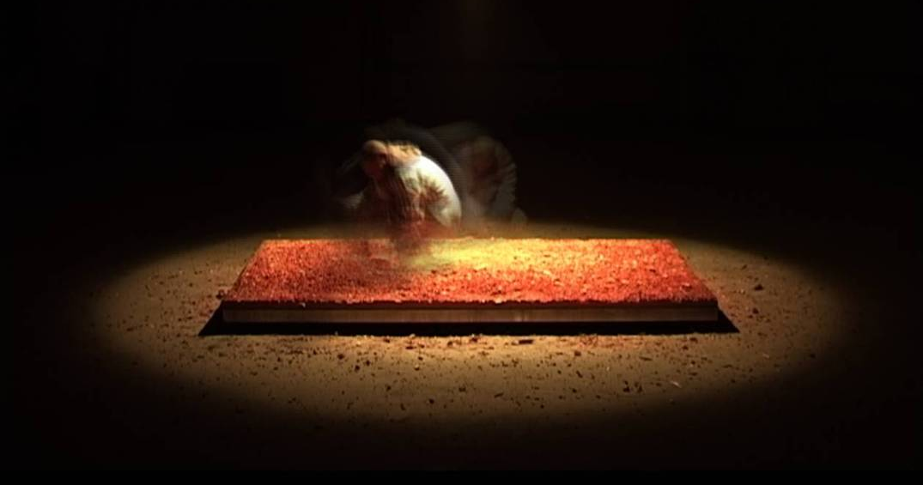

Wang Qingsong: We shot over five nights, because we wanted to use theater style lighting, to get the feeling of being on stage. At first I thought it would be me starring as the solo actor, but I couldn't take it. We used the meat and bones of a whole goat in the shoot, and we had to keep the room temperature cool, or else it would be too smelly. However, we had all the hot theater lighting, so it was tough and inevitably the stench was pretty bad. I couldn't stand the smell of the meat over five days of shooting, and the way it looked as it became blacker and looked more flesh-like.

Because I couldn't stand it, I asked my little brother to act in the shoot. My brother had no problem to do it, and I quickly realized he is a lot tougher than I am. He once worked in a restaurant kitchen, so for him it wasn't so bad. But by the 3rd day, the smell coming off the wood of the stage was pretty bad, and had already made me nauseous. My brother didn't seem to mind, and I realized this also has to do with his life experience. By the end, I joked with him that he could work any where with bad smells with out any problem. He is young and he could do the chopping non-stop for longer than I could. It wasn't easy chopping at that speed through all that meat and bone. We would shoot a few minutes of rapid-fire chopping and then have to stop and restart again, just to maintain the high speed. I found out he is in better shape than I am, he could chop faster for longer without stopping. You have to be in great shape to do this, he exercises much more than I do.
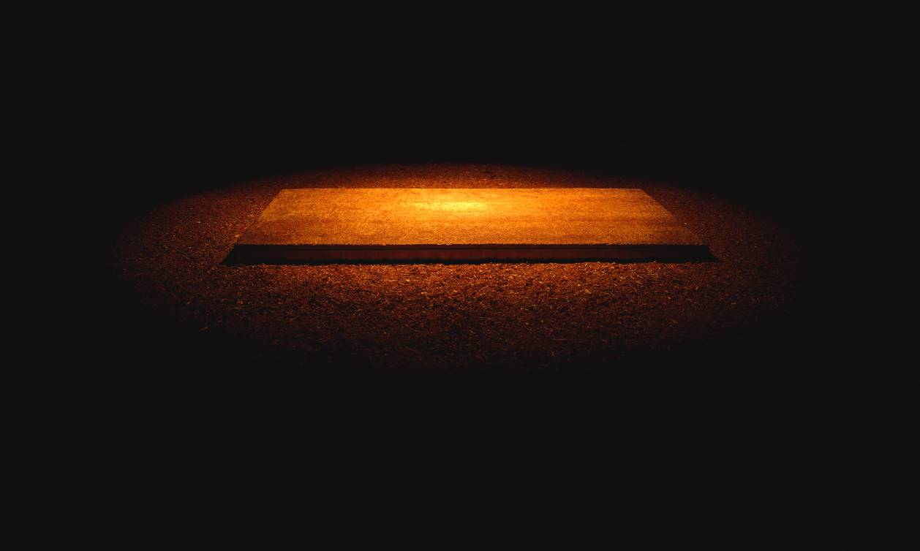
123456 Chops, 120x200cm, 2008

Meg Maggio: I understand you shot these three videos over much of 2008; one in Jan, another in July and finally this one in Oct. I guess while the rest of Beijing was thinking about the Summer Olympics, you were focused on your video work!

What was it like trying to get the videos finished amidst all the pre-Olympics city-wide hyper activity?

Wang Qingsong: Of course it was tough to work in Beijing in the months preceding the Olympics. The cost of doing everything went up, safety inspections increased starting right after Jan 1st 2008. So, I had to find the fastest, most straightforward way to get everything done, I tried wherever possible to expedite, and to limit my problems/hassles.

At the same time, I was working on sculpture works for the Shanghai Biennale. The sculptures were bronze, and the raw materials were stuck in another province, and there were all kinds of delays, while trucks waited in long inspection queues, before moving any cargo into Beijing. There were lots of delays and cost overruns which definitely affected my sculpture in a negative way.
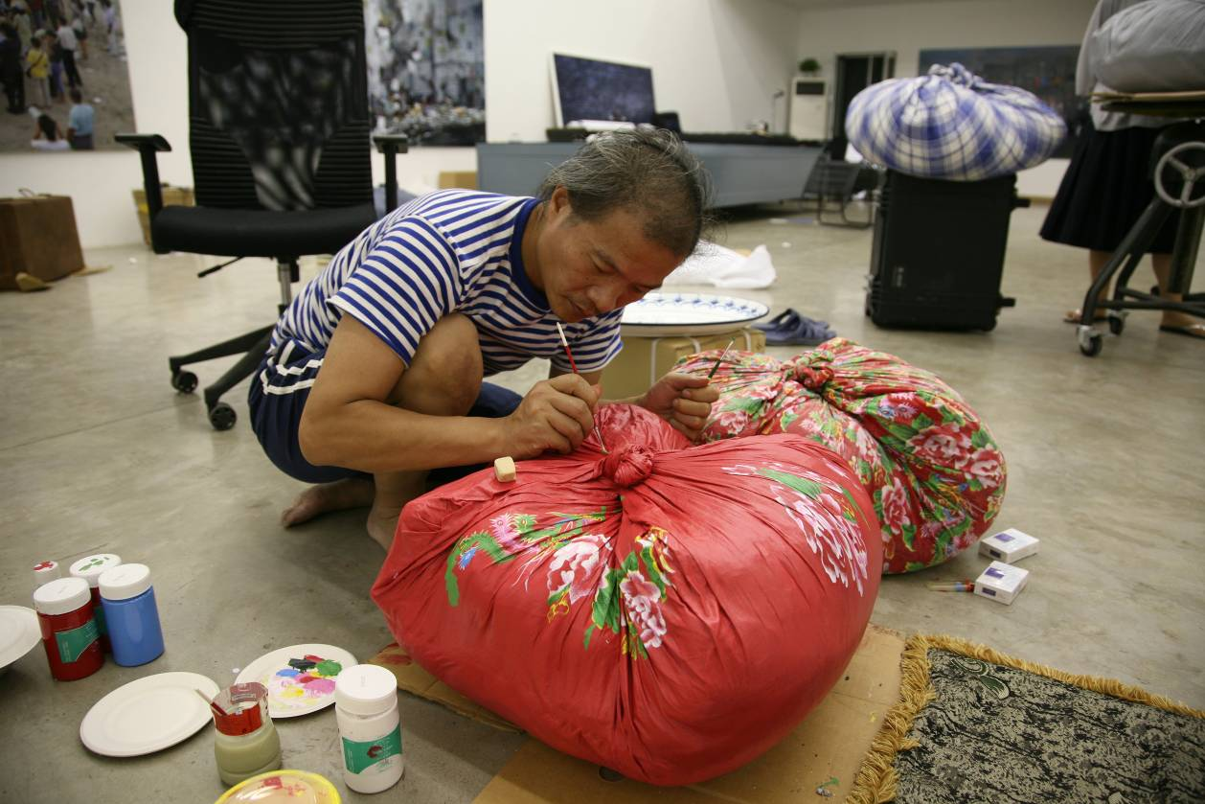

Shooting the videos, there were problems related to hiring people and salaries were inflated. And all construction work of any kind had to stop by June 2008. No construction was allowed thereafter, and all sites had to be cleaned up before the Olympics opening, so workers salaries shot up, in order to get work done within the city-wide deadlines.

Meg Maggio: I see that all three videos are technically reliant on stop-action film shooting techniques. And 2 are shot using 35 mm film later digitalized onto video. "123, 456" is shot on digital. Can you discuss why you chose these particular formats?

Wang Qingsong: It was better to shoot "Skyscraper" on 35 mm because I was always stopping and starting the shoots, much like the way cartoons are made by linking together a series of still images. We shot little bits at a time; the workers would build, then I would ask them to climb down off their scaffolding, so I could shoot the edifice as it grew. I wanted the video to slowly unveil the progress and rhythm of their construction.

In "Iron Man", it was better to use stop-action so the filming could pause frequently so they could apply fresh wax make up to my face. The make-up, in order for me to look realistically beat up, had to be shot in several takes. There is no way I could get the same effect from one continuous take. I had to stop-start and to shoot little segments and later to edit them together. All together, it took about 3 days of shooting.

"123, 456" was shot differently. We had to use more than one chopping knife, switching knives depending on what we were chopping, and shoot over and over again in about 2 or 3 takes. We often had to stop every few minutes during shooting. We shot over five continuous evenings, and it was not easy to shoot all this meat and bone chopping. We eventually chopped up all nearly the entire goat and very little remained to throw away at the end. This took quite a bit of time with many short takes with lots of rests in between.

Meg Maggio: Additionally, all three are without narration or dialogue. Instead, you rely on minimal use of music or sounds associated with the actions to suffice. Do you foresee working with dialogue in future? Why were the words or voices of the protagonists less important to you?

Wang Qingsong. I don't rule out using dialogue scripted or otherwise in future. This time for me, I wanted to create an overall feeling that accumulated over the length of the video. The aim was to create a feeling, a mood and an emotion over time. I think "Skyscraper" for example did not need the sound of a construction site; this would have been too literal and not interesting. I thought "Iron Man" did not need any sound, because it would then look and sound too much like an action movie. Better to let viewers think the protagonist will live through the beating, I find this feeling closer to real life. I didn't want to leave any uncertainty associated with whether the hero would live or die, which is the typical formulaic cliché of most action movies.

Also, in "Iron Man" the guy is smiling, behaving like the more you hit him the more he smiles. I want this ambiguity. We all get hit in one form or another in the life. Perhaps not literally, but figuratively, we face all sorts of "hits" from life, and we face all kinds of difficulties. We learn to eat bitterness. We get spanked by our parents as a child and later we get hit in one way or another by society. Of course I am not negating nor downplaying the violence depicted in the shoot, and I am deliberately leaving ambiguous the ways we choose to interact with such violence whether literal or figurative. 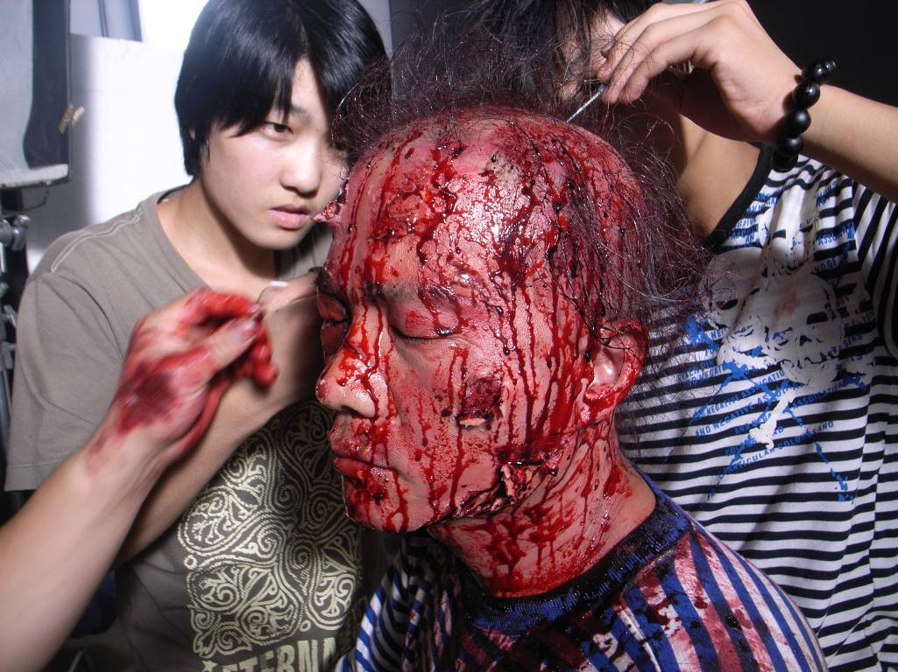

WQS: "Iron Man" is a term that exists in the Chinese lexicon and is used to describe a particular life attitude. An "Iron Man" can confront and overcome life's obstacles, without fear or trepidation, and continue forward. An "Iron Man" is someone unafraid to face and to bear life's vicissitudes. Of course I am using this attitude and this "Iron Man" title with much irony and skepticism.

Meg Maggio: The subject matter of both Iron Man and 123,456 Chops is disturbingly masculine and violent, yet utterly absorbing. What do you think these two videos say in the way they speak to our images of masculinity and in particular masculinity in your personal context as a Chinese male of a certain age living in Beijing?

Wang Qingsong: Yes, these videos are definitely imbued with the general attitude, personality and character we are taught is the ideal male in Chinese society. There is indeed an attitude that men must be like that. Men must be able to withstand fighting, to take hits, to get hit and to take it. All Chinese boys grow up able to fight. Girls are meant to be pretty, and men must be able to fight. That is a common attitude in daily life growing up. Men have various duties in society; they are expected to pick up the tab and to invite everyone for meals, women are not expected to do this. Chinese men have lots of responsibilities/duties they accept automatically as part of our socialization/education process.

Meg Maggio: In a 2003 article by Pi Li on Chinese Contemporary Video Art he depicts video as an attractive new medium for Chinese artists; one free of political history and baggage, as a tool allowing artists to get closer to reality and to critique mass media by literally creating their own means of media-based expression (via video and the web and blogs etc.) How do you see your own video work in this discussion and what relationship does your new video work have to your long experience of working with photography?

Wang Qingsong: Everyone in China at one time or another has the dream of being a film maker or a photographer. We grow up with the dream of being a movie maker. From the time you are a little kid, you have the dream, that when you have money and success, you have enough to build your dream home and to make your own film.

Now, of course attitudes and fashion are changing. I remember when I was making my "Past, Present, Future" photo tableaux, I started to think about how great it would be to show the movements during the making of the shoot and how well this work could translate into video. Now, when I look at the "Past, Present, Future" photo, I feel something missing, less emotional resonance perhaps, coming from the stationary "Past, Present, Future" image. Now, I start to imagine that an element of movement in some circumstances can potentially add more to a story.
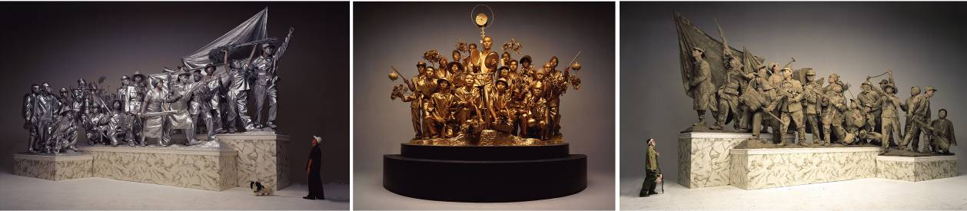
Past, Present and Future, 2001

I'm planning on shooting new work, using a film or tv program genre, complete with a script and a strong story-line. It could be a feature film or a tv mini-drama serial with multi-parts. I am also working on a project entailing all the components of a typical day of Chinese television programming; with stories, news, weather reports and ads, and put it all together in a 12 hour program of my own making. I am fascinated by Chinese tv programs, how they are made, how they can entertain and move people. I think I could make great continuous TV programming if I had 12 hours of program viewing time. I hope to make something like this in future, perhaps in stages over the next 3 to 4 years. Or shoot a short documentary. The more I fly to various overseas exhibit locales, the more tv and film I've watched, and the more I think, I can do better.

WQS: Yes, I agree that good video can more closely approximate reality as Pili says, and generally touch reality more closely than photo-based work.

Meg Maggio: Finally, could you tell us a little bit about what you are working on these days, thanks!

Wang Qingsong: I worked this year on a monumental historic photo project. It's a color photo, Chinese traditional hand scroll style, depicting various characters and heroes of history both ancient and modern. The photo has the people set in bronzed stone relief in a kind of three dimensional memorial stone tableaux to history. It's 40 meters long and I just finished editing. Now, I am thinking of how it can be installed for viewing.

I also shot my own imitation of a tv ad, around the subject of on losing weight, staying healthy, working out, exercise. These are new video projects I am currently working on, as part of my long term project involving shooting12 hours of tv programming time. The tv commercial shoot is one of my own invention, where I employ real actors. I will also use all the other tv genres: News programming, mixing real with fake; weather programs; tourism programs; perhaps language training programs. I watch quite a bit of television, and frankly, I think I can do better.

- Meg Maggio, Oct 2, 2009

Skyscraper (2008) DVD from 35 m film, 5 min (Jan)
123,456 Chops (2009) DVD from 35 mm film (Oct)
Iron Man (2009) DVD from 33 mm film (July)

Meg Maggio
Director

Pékin Fine Arts
No. 241 Cao Changdi Village
Cui Ge Zhuang Xiang
Chaoyang District, Beijing 100015
T (8610) 5127 3220
F (8610) 5127 3223
E info@pekinfinearts.com
www.pekinfinearts.com

Open: Wed - Sun 10:00am to 6:00pm
Mon - Tues By appointment

